Spring2026 Final
Write a method/function called evenMax() that takes a MaxHeap object as a parameter and returns the same MaxHeap object containing only the even-valued elements. The method/function should also print the number of discarded odd values.
Assume a MaxHeap class is already implemented with public methods insert(), extractMax(), and getSize(), and private methods sink() and swim()[In this case, swim() and sink() won't be used. Just because it's given in the question, that does not mean you have to use it].
Only the public methods can be used after creating a MaxHeap object. The getSize() method returns the size of the heap. You can create extra MaxHeap objects to solve this.
Note: You must use MaxHeap to solve the problem. You’re not allowed to use any other data structures.
Given Heap Object | Sample Output | Explanation
MaxHeap: [X, 15, 8, 10, 6, 7, 3, 2] | Discarded: 3 | A total of 3 odd numbers were extracted from the heap.  The returned heap: [X, 10, 8, 6, 2 ]

public static MaxHeap evenMax(MaxHeap heap) {

MaxHeap evenHeap = new MaxHeap(heap.getSize());

int discarded = 0;
while (heap.getSize() > 0) {

int value = heap.extractMax();
if (value % 2 == 0) {
evenHeap.insert(value);
}
else {
discarded++;
}
}
System.out.println("Discarded elements: " + discarded);

while (evenHeap.getSize() > 0) {
heap.insert(evenHeap.extractMax());
}

return heap;
}
Summer2025 final
You are given an array of tasks, where each element represents the urgency level of that task and a deadline (number of days available). Your job is to complete the possible tasks within that deadline.
However, there are a few rules:
- Each task takes 1 day to complete.
- At each step, complete the task with the highest urgency.
- Ignore tasks left after the deadline.
The time complexity of your solution must be less than O(n²). Assume that the classes MaxHeap and MinHeap are provided with all necessary methods, including insert(value) and extract(), where extract() returns the removed element.
Input | Output | Explanation
tasks = [30, 95, 80, 25,50]  deadline = 3 | Day 1 - Urgency 95  Day 2 - Urgency 80  Day 3 - Urgency 50  Tasks completed: 3  Tasks ignored: 2 | Here, the deadline is 3 days and tasks 2, 3 and 5 have the highest urgency. So, they will be done in their respective urgency order. The rest of the tasks will be ignored.

static void urgent_task(int[] tasks, int deadline) {
MaxHeap maxHeap = new MaxHeap(tasks.length);

// Insert tasks using regular for loop
for (int i = 0; i < tasks.length; i++) {
maxHeap.insert(tasks[i]);
}

int completed = 0;
// Process tasks up to deadline
for (int day = 1; day <= deadline; day++) {
int val = maxHeap.extractMax();
System.out.println("Day " + day + " - Urgency " + val);
completed++;
}

int ignored = maxHeap.getSize(); //int ignored=tasks.length-deadline
System.out.println("Tasks completed: " + completed);
System.out.println("Tasks ignored: " + ignored);
}

Fall 2025 Final
Your task is to implement a method/function scanMaxInGroup(numbers, k) that:
- takes an array of integers named numbers, where elements are stored in random order.
- takes an integer k, representing how many integers you need to group.
- returns an array containing the maximum numbers for each group in sequential order. (Meaning “maximum of each consecutive group of size k”)
A Max Heap class is already provided with all required functionality. You can use its public methods insert() and extract() after creating its object.
Note: You must use MaxHeap to solve the problem. You’re allowed to create only 1 integer array.
Hint: [array length]
Number of groups = Number of elements − Group size + 1 = n - k + 1.
[it was Given during the exam as a hint]
Given parameters & Method/Function Call | Sample Returned Array | Explanation
nums = [1, 3, -1, -3, 5, 3, 6]  k = 3  scanMaxInGroup(numbers, k) | [3, 3, 5, 5, 6]  groups= len-k+1 | The radar observes 3 numbers at a time and records the highest number for each observation:  [1, 3, -1] → 3,  [3, -1, -3] → 3,  [-1, -3, 5] → 5,  [-3, 5, 3] → 5,  [5, 3, 6] → 6
nums = [2, 1, 5, 3, 4, 6]  k = 4  scanMaxInGroup(numbers, k) | [5, 5, 6] | The radar observes 4 numbers at a time and records the highest number for each observation:  [2, 1, 5, 3] → 5,  [1, 5, 3, 4] → 5,  [5, 3, 4, 6] → 6

static int[] scanMaxInGroup(int[] numbers, int k) {

// Handle invalid cases: empty array or invalid window size
if (numbers == null || k <= 0 || k > numbers.length) {
return;
}

int n = numbers.length;

// Result array to store maximum of each group (only integer array allowed)
int[] result = new int[n - k + 1];

// Slide the window from index 0 to (n - k)
for (int start = 0; start <= n - k; start++) {

// Create a MaxHeap for the current group of size k
MaxHeap heap = new MaxHeap(k);

// Insert k consecutive elements into the heap
for (int i = start; i < start + k; i++) {
heap.insert(numbers[i]);
}

// Extract and store the maximum element of the current group
result[start] = heap.extractMax(); // result[start] = heap.getMax();
}

// Return array containing the maximum of each group
return result;
}

1. In the sink/heapify operation of the remove function in a Max-Heap, with which child is the value of a node compared? [1 Mark]
a) Left child b) Right child
c) The greater among its two children
d) The minimum among its two children
Answer: c) The greater among its two children
Explanation: In a max-heap, to maintain the heap property, you compare with the larger child and swap if needed.

2) You are given a Max-heap tree, but due to memory corruption, a node is violating the max-heap property.

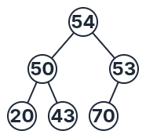
Using the concepts of Swim() or Sink() (to move a value up or down the heap), update the tree so that it becomes a valid max-heap again .
Note: You are not allowed to remove any elements from the tree. No need to write any codes.
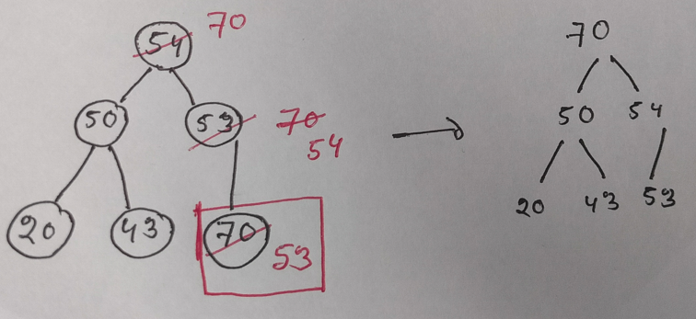
3. The Worst-case Time Complexity for the insert operation of a heap and an unbalanced BST is the same.
Answer:False
Explanation: Heap insert is O(log n), while unbalanced BST insert can be O(n) in the worst case.

4. Duplicate values are allowed in a HEAP.
Answer:True
Explanation: Property 4 of Heap.

